Mat E 272
Fall 2001 – Lectures 5 & 6

Imperfections in Solids

There is no such thing as a perfect crystal!
- Thermodynamically “impossible”
- “defects” lower the energy of a crystal & make it more stable
- always have vacancies, impurities to some extent

“Defect” does not necessarily imply a “bad” thing
- addition of C to Fe to make steel
- addition of Cu to Ni to make thermocouple wires
- addition of Ge to Si to make thermoelectric materials
- addition of Cr to Fe for corrosion resistance
- introduction of grain boundaries to strengthen materials

and so on…

“Defect” (in this context) can be either desirable or undesirable. In general, a defect simply refers to a disruption in the crystalline order of an otherwise periodic material.

Types of defects (or imperfections):

- one-dimensional (point)

vacancy → a lattice site that is missing an atom:
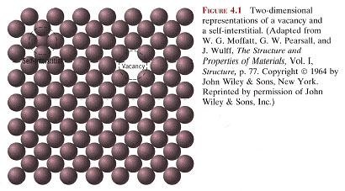

(all crystals contain some vacancies)

let N_{v} = equilibrium # of vacancies (at a given absolute temperature, T)

then
This is called an Arrhenius equation, after Svante August Arrhenius, a Swedish chemist who won the Nobel prize in chemistry in 1903.

$$N_{v}=N_{o}\text{exp}\left(−\frac{Q}{\text{kT}}\right)$$

where N_{o} = total number of lattice sites
k = Boltzman’s constant (1.38x10⁻²³ J/atom/-K or 8.62x10⁻⁵ eV/atom-K)
Q = activation energy for vacancy formation (how much energy is required to “pull” an atom out of its lattice site)

(Q is generally on the order of ~1 eV/atom)

taking logarithms of both sides of the above equation:

$$\text{ln}(N_{v})=\text{ln}(N_{o})−\frac{Q}{k}\frac{1}{T}$$

or

$$\text{ln}\left[\frac{N_{v}}{N_{o}}\right]=−\frac{Q}{k}\frac{1}{T}$$

so, a plot of $\text{ln}\left[\frac{N_{v}}{N_{o}}\right]$ versus $\frac{1}{T}$ should yield a straight line with slope = -$\frac{Q}{k}$

The quantity $\left[\frac{N_{v}}{N_{o}}\right]$is just the fraction of lattice sites that are vacant.

Note: exp(-Q/kT) is a strong function of temperature

Example:

Calculate the fraction of atom sites that are vacant for lead at its melting temperature of 327°C (=600 K). Assume an activation energy of 0.55 eV/atom.

In order to compute the fraction of atom sites that are vacant in lead at 600 K, we must employ Equation (4.1). As stated in the problem, Qv = 0.55 eV/atom. Thus,

= exp = exp = 2.41 x 10-5

example: Fractional vacancy concentration in lead:

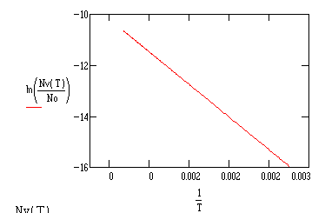
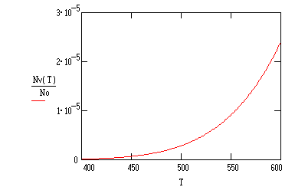

self-interstitial → an atom from the crystal that crowds its way into an otherwise empty void between atoms

self-interstitials are far less common than vacancies because of the relatively large energy required to squeeze an atom into the small voids between existing sites. (results in a large strain field)

impurity → addition of an atom of a different species than the “host” or matrix

Alloys – other types of atoms are deliberately added to give the material certain properties

- May or may not result in the same crystal structure
- May or may not result in secondary phases

Example 1: add 1% Sn to Pb (i.e., of every 100 Pb lattice sites, 1 is occupied by a Sn atom)

Result: single phase “alloy” (same crystal structure as pure Pb, no regions containing different chemical stoichiometry)

Example 2: add 25% Sn to Pb

Result: a “two-phase” microstructure (distinct regions of Sn)

“solubility” of Pb (in the solid state) is exceeded

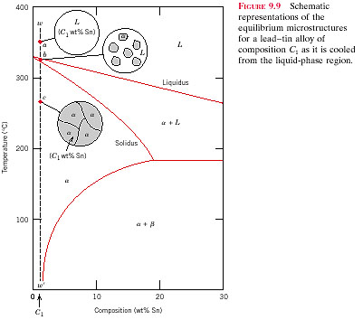
This is an example of a “phase diagram” for the Pb-Sn system. It specifies what phases exist under equilibrium conditions at any given temperature.

Phase diagrams will be discussed in more detail in Chapter 9.

solid solution –

- A homogeneous distribution of two or more elements.
- “solute” atoms are added without altering the crystal structure or resulting in formation of a new phase.
- Solid solution is a particular type of alloy
- Two types: substitutional and interstitial

“solvent” – the host material, usually the element or compound present in the greatest amount.

“solute” – the minor phase, added to the solvent. Usually the element or compound present in minor concentrations.

(informally, you add solute to a solvent to make a solution)

“phase” is a region of uniform composition or crystal structure

What would a solid solution look like?

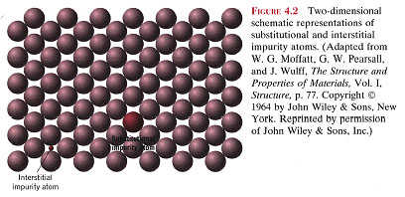
An idealized solid solution alloy

Note that the substitutional atom fits nicely in the lattice site, without generating a strain field
Substitutional atom
interstitial atom

Not all elements form solid solutions. There are very specific rules that govern the extent to which solid solutions can form:

General guidelines for predicting solid solubility between any two elements:

For appreciable solubility to occur the following factors must hold:

- Atomic size factor
the difference in atomic radii between the two atoms must be ≤ ± 15%
- Electronegativity

the difference in electronegativity between the two atoms must be ≤ ± 0.4
- Crystal structure

The crystal structure of each element must be the same
- Valence
For a given solvent, a solute with a higher valency is more likely to be soluble than one of lower valency, all other factors being equal.

Collectively, these rules guide predictions of solid solubility.

(The first two conditions, size difference and electronegativity difference, constitute the Darken-Gurry criteria)

The following is an example of a Darken-Gurry ellipse for Nb:

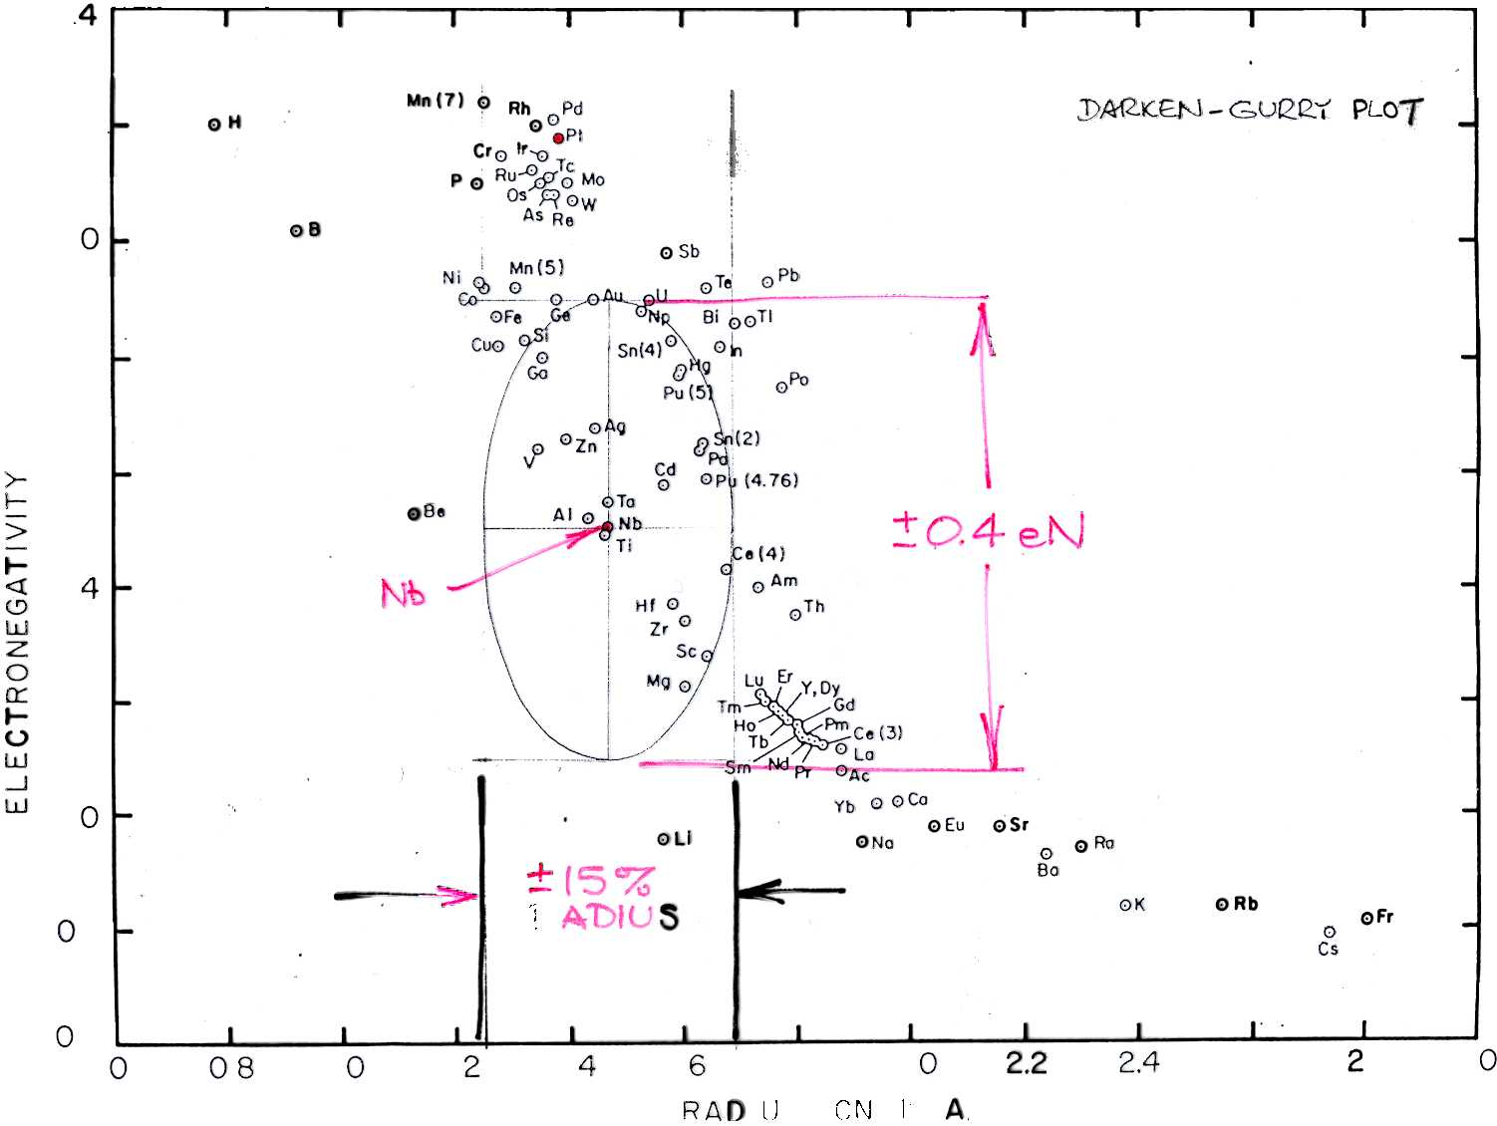

Composition and conversion between weight and atomic percent:

Mixtures (i.e., composites) or alloys of two (or more) elements, are quantitatively described in terms of composition:

Consider a mixture of B in A:

X 100%
weight percent B = mass of B = C_{B}
total mass of A + B

atomic percent B = # moles of B = C’_{B}

X 100%
total # moles of A + B

Conversion from weight to atomic percent (and vice versa):

- atomic percent to weight percent:

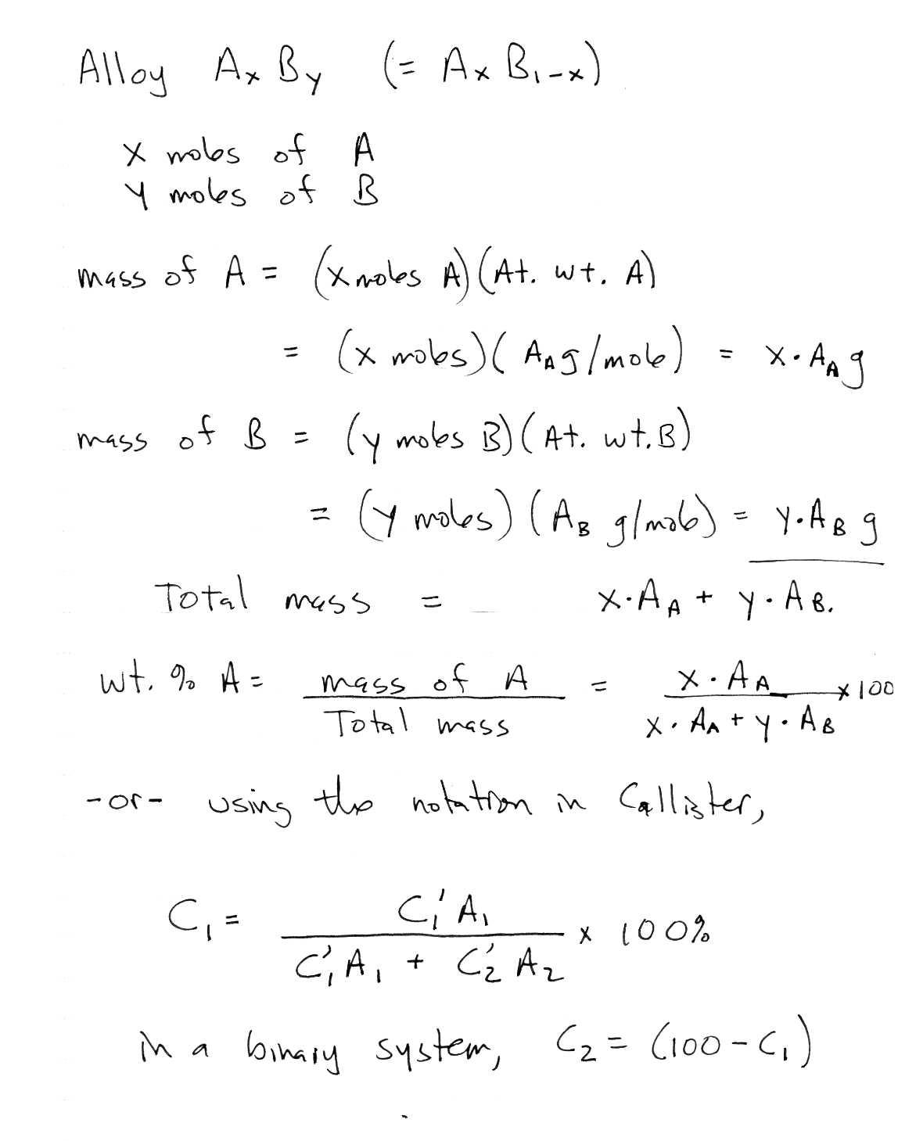

- weight percent to atomic percent:
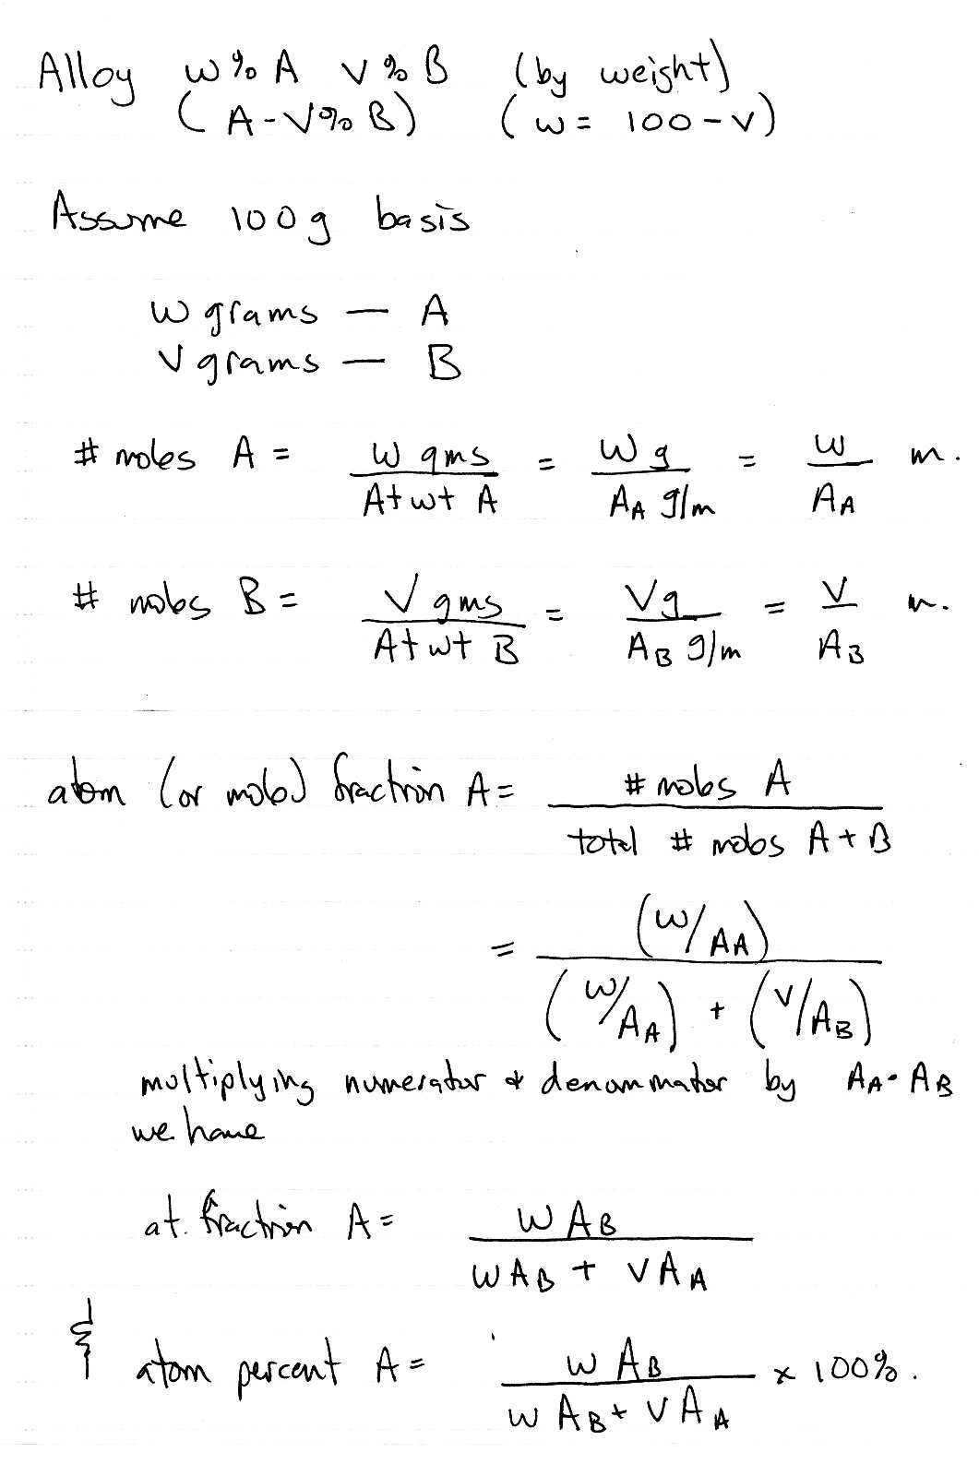
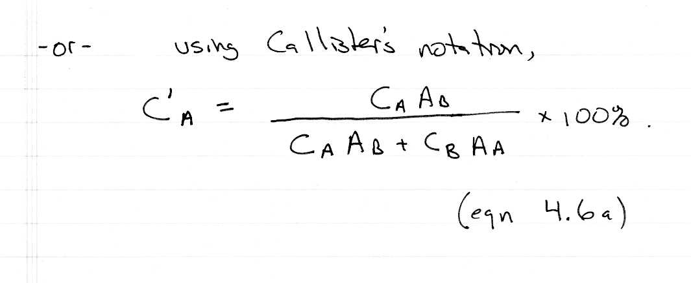

Example: what is the composition, in atom percent, of an alloy consisting of 30 weight % Zn and 70 weight % Cu?

In order to compute composition, in atom percent, of a 30 wt% Zn-70 wt% Cu alloy, we employ Equation (4.6) as

CZn= x 100

= x 100

= 29.4 at%

CCu= x 100

= x 100

= 70.6 at%

- two-dimensional (linear)

Most common types of linear defect are dislocations, grain boundaries, twins, and external surfaces.

think of a dislocation as an extra half-plane of atoms inserted in a crystal:

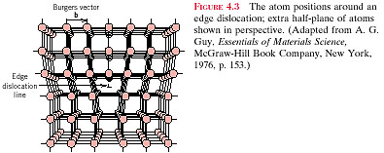
Slip plane

Dislocations result from solidification from the melt, from mechanical work (e.g., rolling, swaging, drawing, compressive impact, tensile or shear stress), or from thermal stresses

It is very difficult to prepare a dislocation-free crystal!!!

Dislocation motion is the primary mechanism responsible for the strength and ductility behavior of metals

As a metal is deformed (in tension), the density of dislocations increases and they begin to interact with each other. This interaction is responsible for the observed increase in strength. (cold working is an excellent example – try it sometime with an old spoon)

To a first approximation, the energy required to move an edge dislocation is ZERO (although in reality, a finite amount of energy given by the Peierls-Nabarro force, is required to move a dislocation)

(energy req’d to stretch a bond on one side = energy released in contracting a bond on the other side)

This is why the strength of metals << theoretical strength

If edge dislocations exist on slip systems, their motion will occur at a very low shear stress and will produce “slip”

Example of slip caused by movement of an edge dislocation:

1). 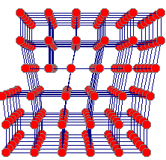2) 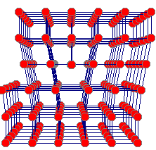3)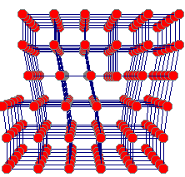
4)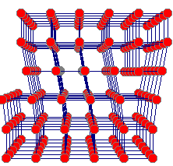5) 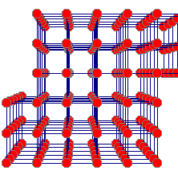

Note how a shear stress causes the atoms to slip by one atomic spacing

Edge dislocations can climb or glide.

Burger’s vector gives the magnitude and direction of the lattice distortion associated with a dislocation. Burger’s vector is determined from the error in closure around a dislocation core.

(large Burger’s vectors imply higher activation energy for slip.)

The presence of dislocations in crystals, and their ability to move (and multiply) under applied stress, permits plastic deformation.

Plastic deformation is a permanent change in shape resulting from an applied stress (tensile, compressive, or shear).
There is another type of dislocation…called a screw dislocation:

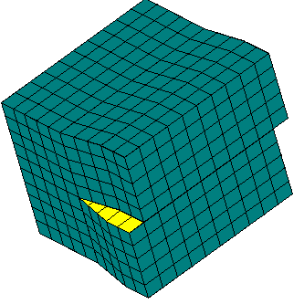

The motion of a screw dislocation can be thought of in terms of tearing a sheet of paper.

Usually, dislocations have both an edge and a screw character; i.e., they are mixed dislocations:

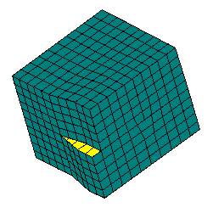

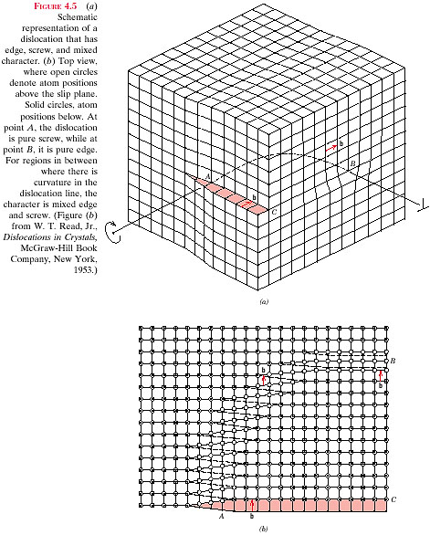
Pure screw here
Pure edge here
Mixed mode here
Slip plane

top view of the above crystal:

edge
screw
Atom positions above the slip plane indicated by open circles;
Atom positions below the slip plane indicated by filled circles

Dislocation motion is the primary mechanism responsible for cold work strengthening and plastic deformation in metals.

Slip = movement of dislocations under the action of an applied stress

Slip planes are close-packed planes / slip occurs in close-packed directions
Dislocation density and observation:

dislocation density = total length of dislocation

volume of the crystal

Units: cm/cm³

Typical metals: ρ_{dl} ~ 10⁶ to 10⁷ cm/cm³

Heavily cold-worked metals: ρ_{dl} ~ 10¹³ cm/cm³

Are dislocations stable?

Test: heat to a high temperature (but < T_{m})

Conclusion: they are NOT stable

Observation:

Need high magnification ( => TEM)

Example: (Ti at 51,000 x)

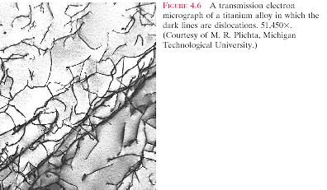

Other two dimensional “defects:”

External surfaces

- atoms are in a high energy state
- surface energy expressed in J/m³
- materials try to minimize surface energy

(this is why liquids assume spherical shapes)

Grain boundaries

- interfacial region separating single crystalline volumes
- usually only a few atoms wide
- higher energy than bulk, but lower energy than external surface
- many physical properties are determined by grain size

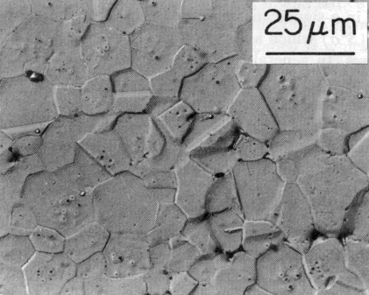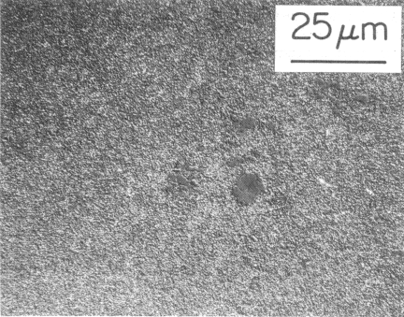
Note the difference in grain size between these two materials

- Grain boundary orientation:

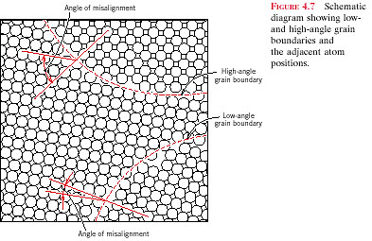

high angle grain boundaries are in a higher energy state than low angle grain boundaries (affects the behavior of the material (diffusion, creep))

Twin boundaries:

A disruption in the atomic stacking sequence
- Results in a “mirror plane” symmetry:

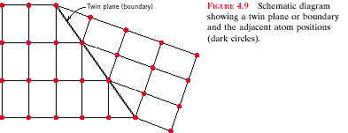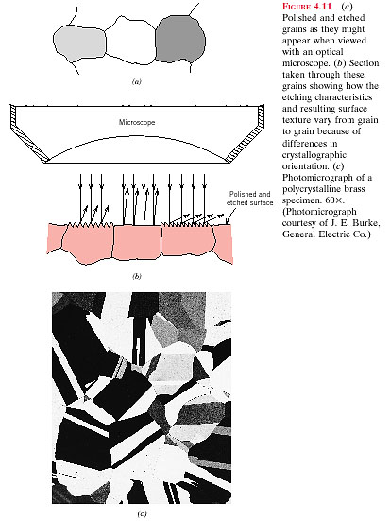

- Twins are formed during mechanical shear stresses (mostly BCC and HCP metals) and during heat treatments (annealing twins – mostly in FCC metals)

- three-dimensional (volumetric) defects

- second phase inclusions
- porosity
- cracks

Microscopy:

Optical

Usually need polished and etched surfaces

Polishing → grinding or sanding with successively finer grits. (Best results with a mirror-like finish)

Chemical etching attacks surfaces (and grain boundaries) differently depending on orientation:
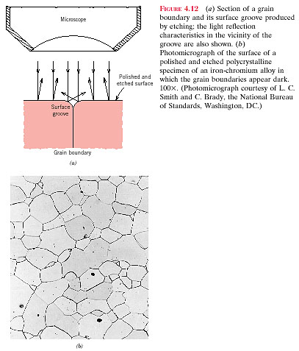

(typically use acids or combination of acids to achieve proper etching)

important point: grains are 3-D artifacts, not 2-D. Microscopy only gives 2-D images of 3-D entities.

The “resolution limit” of any imaging system depends on its wavelength through the relation

(Δϕ)_{min} = 1.22λ/D

where λ is the wavelength, D is the aperture diameter, and (Δϕ)_{min} is the minimum resolvable angular separation

Optical microscopy: λ ~ 600 nm (or 0.6 micron)

optical resolution limit ~ 3,000x ⇒ cannot see details smaller than ~ 0.1 micron with an optical microscope

Grain Size:

Need a quantitative way to describe the average size of grains in a polycrystalline sample. How do we determine the “grain size” in the following 100X micrograph of a wrought recrystallized BCC alloy?

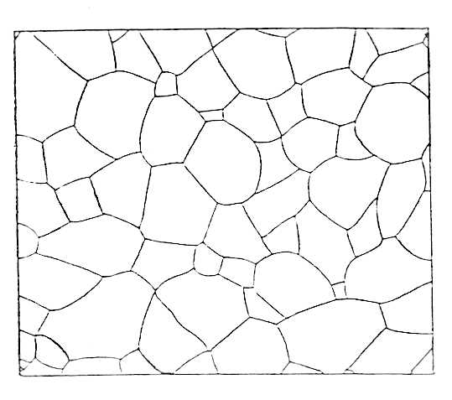
2.75”
3.18”

ASTM method:

- polish a section of the metal
- etch surface with appropriate etchant to expose the grains
- examine under an optical microscope
- photograph typical region at a magnification M
- determine # of grains per square inch in a micrograph at 100X ( =N₁₀₀)

$N_{\text{100}x}=2^{g−1}$ where g = ASTM grain size number

(if the magnification is NOT 100x, then first determine N₁₀₀ using the relationship

$$N_{\text{100}x}=N_{M}{\left(\frac{M}{\text{100}x}\right)}^{2}$$

N_{100x}  Coarse-grained | g
½ | 0
1 | 1
2 | 2
4 | 3
8  Fine-grained | 4
16 | 5
32 | 6
64 | 7
128  Ultra-fine-grained | 8
256 | 9
512 | 10

How to determine the number of grains per square inch:

Determine # of whole (interior) grains in micrograph ( = A)
Determine # of partial (peripheral) grains in micrograph ( = B)
Let total # of grains = A + ½(B)

Taking the above drawing as an example,

Dimension of micrograph = 3.18” x 2.75”

A ≅ 37
B ≅ 38

Then,

$N_{\text{100}x}=\frac{\left(A+\frac{B}{2}\right)}{\left(3\text{.}\text{18}\text{x2 }. 75\right)}$≅ 6.4

now, N_{100x} = 2^{g-1} = 6.4

so g = 3 – 4 (don’t report fractional grain size number)

(the smaller the grain size, <generally> the stronger the material.

Grain size has a huge effect on mechanical properties)

Non-optical imaging technologies:

Electron (SEM, TEM)

Resolution limit is a function of wavelength

If we use electrons instead of light…

λ ~ 0.003 nm

concept: use a focussed beam of electrons to image an object

SEM: scanning electron microscope

- e- beam interacts with (bulk) specimen under observation
- produces a variety of effects (backscattered electrons, secondary electrons, Auger electrons, x-rays)
- magnification up to ~ 100,000X (field emission instruments)
- excellent depth of field
- conductive samples
(environmental SEM operates with either conductive or non-conductive specimens)
- can use to obtain chemical analysis on small volumes
- requires moderate expertise

Examples of depth of field in an SEM: (courtesy of Prof. Scott Chumbley – ISU MSE Dept.)

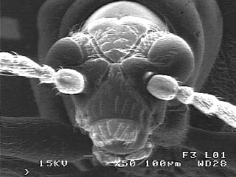
Beetle head

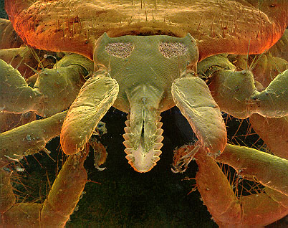
Deer tick

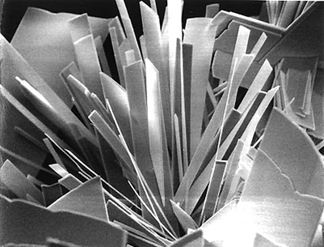
MoO₃ crystals

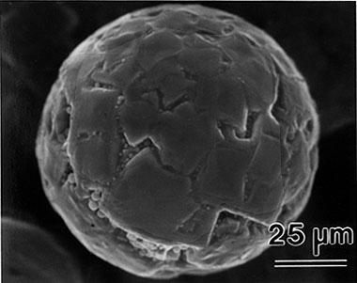
powder particle

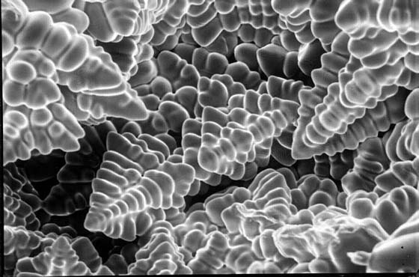
dendrites
TEM: transmission electron microscope

- e- beam is passed THROUGH a thin specimen
(scattering of e- by atoms in the specimen)
(sample preparation requires considerable effort)
- magnification up to ~ 1,000,000X
can perform very localized chemical analysis (x-ray)
- requires considerable expertise

relatively recent innovations: STM, SFM

